GL Account Posting

S.NO 04 -FI-GL-01

TRANSACTION CODE FB50/ F-02

ACCESS PATH SAP Easy Access → Accounting → FinancialAccounting→ General Ledger → Document Entry → GL Account Posting

We get “GL Account Postings” Screen

In the above mentioned screen enter the relevant fields viz. Document date, GL
Account number, and amount.

Press Enter

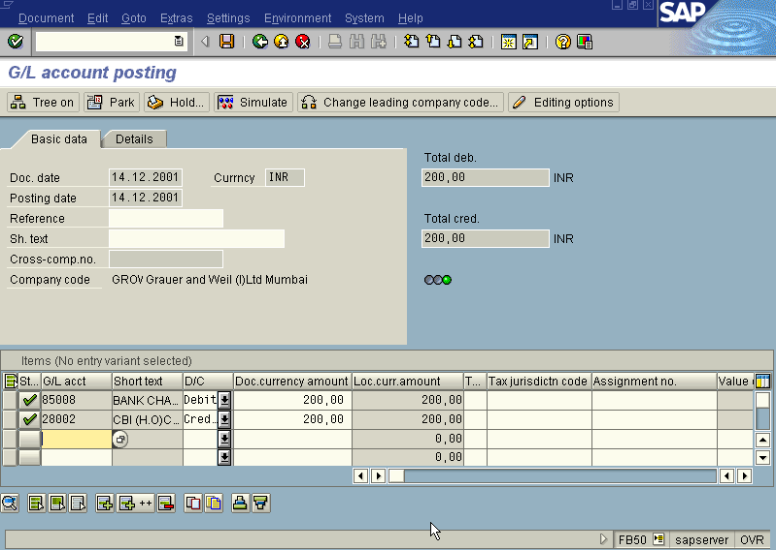
Incorporating the entered fields the system displays the screen as under

Press Save/ Post

The System displays the message with Document number. Take note of the
document number eg. 100086.

To display the entries passed press FB03 or Go to top of the screen and select
Document → Display. The system displays the overview screen as under
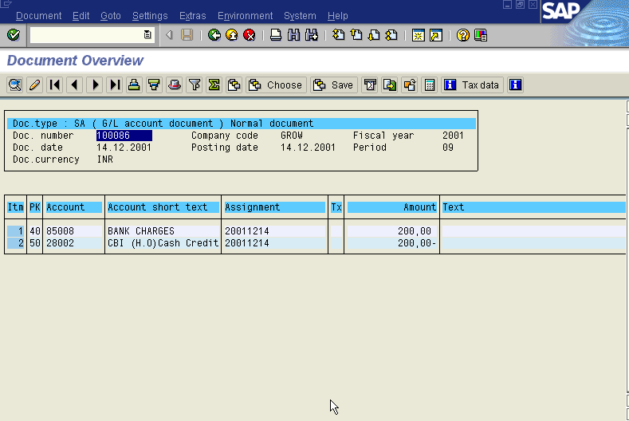

Posting a GL Account with Transaction code F-02

ACCESS PATH SAP Easy Access → Accounting → FinancialAccounting→ General Ledger → Document Entry → Other →General Postings

We get “ Enter GL Account Postings – Header Data” Screen

Enter the relevant fields Document Date, Posting Key 40 for GL Debit and 50 for GL
Credit.

We get the screen as under

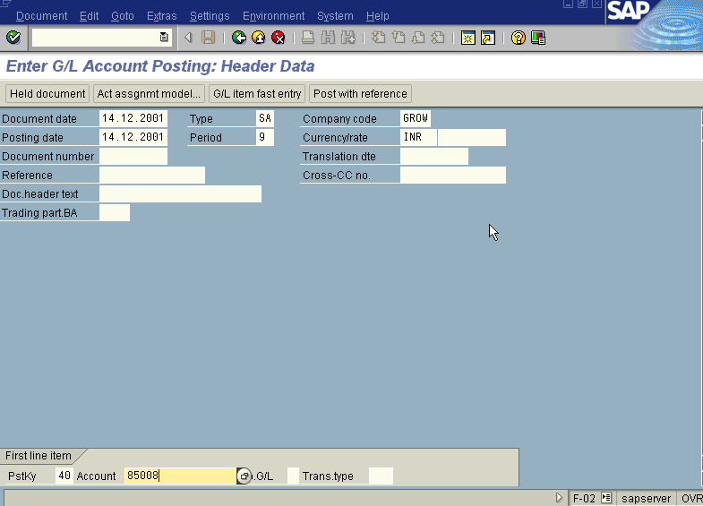
Press Enter
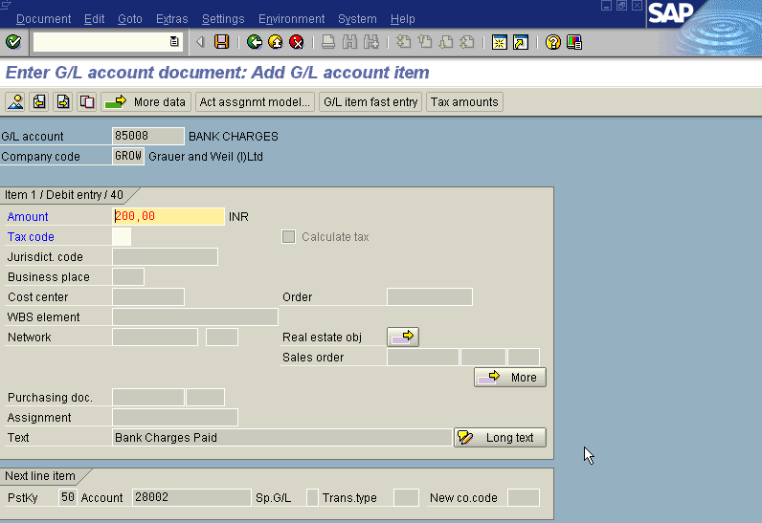

Press Enter

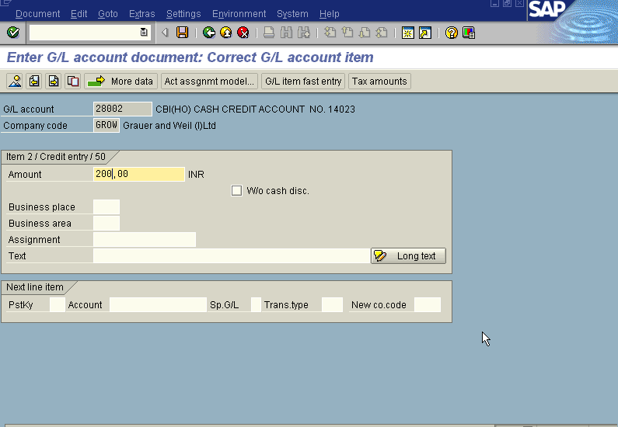

Press Post/ Save

The system displays the message with document number. Take note of the document
Number eg:100087

To display the entries passed press FB03 or Go to top of the screen and select
Document → Display. The system displays the overview screen as under
